Create WebApi Project

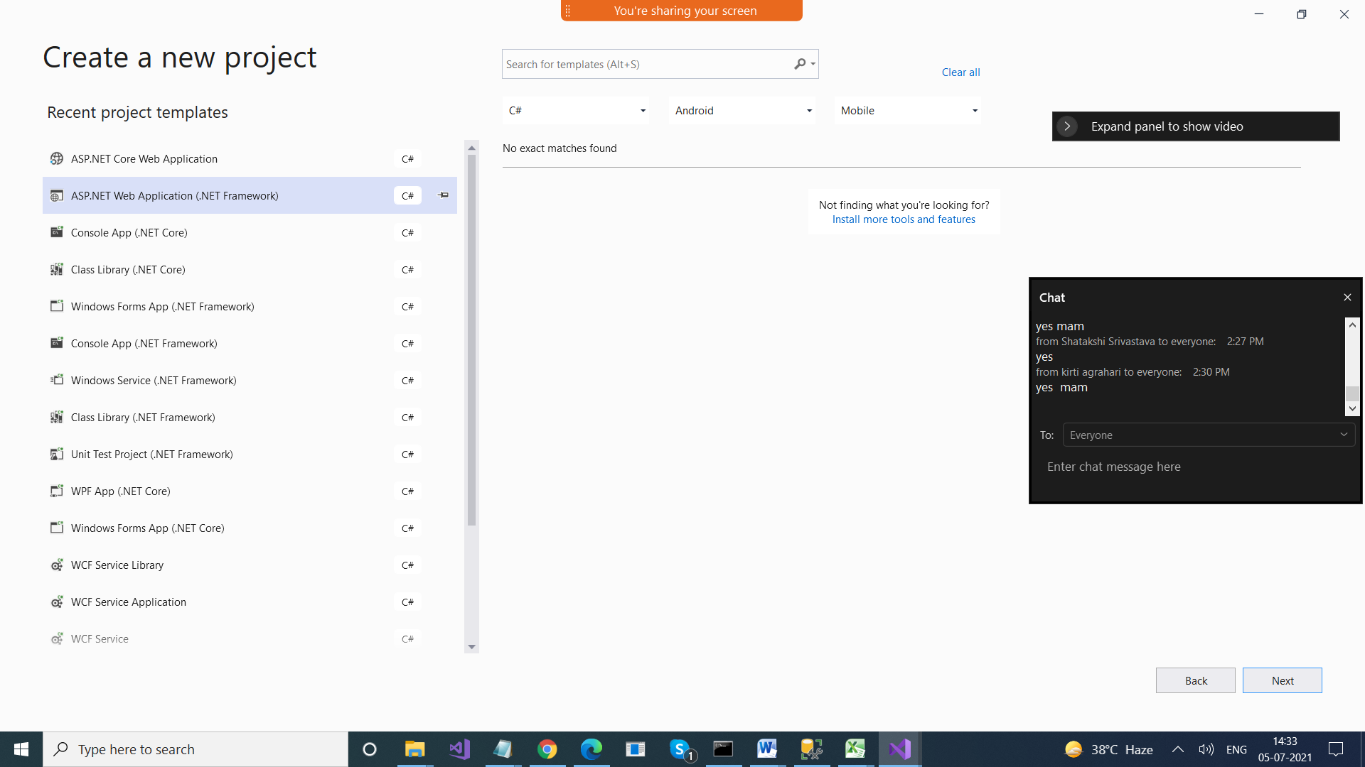



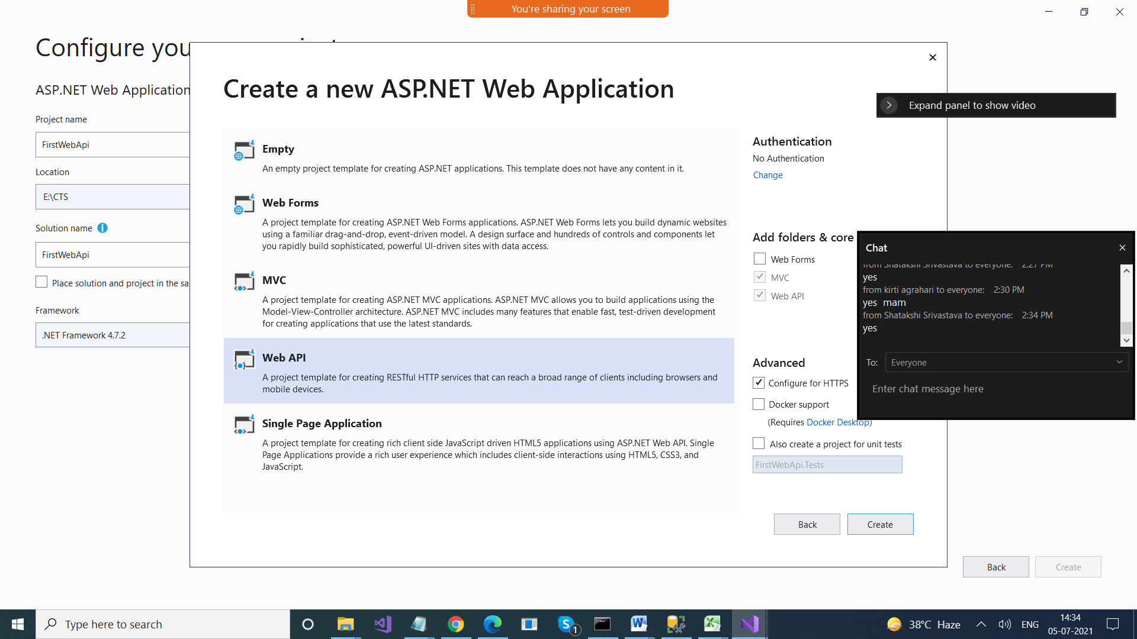

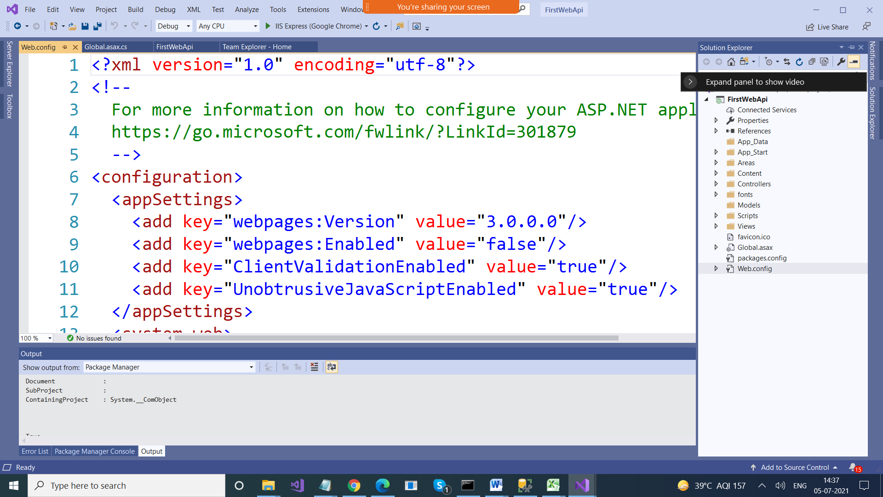

ValuesController.cs file

using System;

using System.Collections.Generic;

using System.Linq;

using System.Net;

using System.Net.Http;

using System.Web.Http;

namespace FirstWebApi.Controllers

{

**public class ValuesController : ApiController**

{

// GET api/values

public IEnumerable<string> Get()

{

return new string[] { "value1", "value2" };

}

// GET api/values/5

public string Get(int id)

{

return "value";

}

// POST api/values

public void Post([FromBody] string value)

{

}

// PUT api/values/5

public void Put(int id, [FromBody] string value)

{

}

// DELETE api/values/5

public void Delete(int id)

{

}

}

}

In the Browser > <https://localhost:44342/api/Values>

<ArrayOfstring xmlns:i="http://www.w3.org/2001/XMLSchema-instance" xmlns="http://schemas.microsoft.com/2003/10/Serialization/Arrays">

<string>value1</string>

<string>value2</string>

</ArrayOfstring>

We will create a class, We will perform CRUD operations on Collection of that Class (In Memory)

Create a class Student in Models folder

Student.cs

using System;

using System.Collections.Generic;

using System.Linq;

using System.Web;

namespace FirstWebApi.Models

{

public class Student

{

public int StudentId { get; set; }

public string Name { get; set; }

public String Batch { get; set; }

public int? Marks { get; set; }

public DateTime? DateOfBirth { get; set; }

}

}

--------------------------------

StudentsController.cs file

using System;

using System.Collections.Generic;

using System.Linq;

using System.Net;

using System.Net.Http;

using System.Web.Http;

using FirstWebApi.Models;

namespace FirstWebApi.Controllers

{

public class StudentsController : ApiController

{

static List<Student> students = null;

public StudentsController()

{

if(students == null)

{

students = new List<Student>()

{

new Student() { StudentId = 1, Name = "Ajay", Batch = "B001", Marks = 90, DateOfBirth = Convert.ToDateTime("12/12/2001") },

new Student() { StudentId = 2, Name = "Deepak", Batch = "B003", Marks = 78, DateOfBirth = Convert.ToDateTime("10/06/2020") },

new Student() { StudentId = 3, Name = "Sagar", Batch = "B002", Marks = 98, DateOfBirth = Convert.ToDateTime("10/06/2020") },

new Student() { StudentId = 4, Name = "Pradeep", Batch = "B002", Marks = 80, DateOfBirth = Convert.ToDateTime("10/06/2020") }

};

}

}

// GET: api/Students

public IEnumerable<Student> Get()

{

return students;

}

// GET: api/Students/5

public Student Get(int id)

{

return students.FirstOrDefault(x => x.StudentId == id);

}

// POST: api/Students

public void Post(Student student)

{

students.Add(student);

}

// PUT: api/Students/5

public void Put(int id, Student student)

{

Student obj = students.FirstOrDefault(x=>x.StudentId == id);

if (obj!=null)

{

foreach(Student temp in students)

{

if(temp.StudentId == obj.StudentId)

{

temp.Name = student.Name;

temp.Batch = student.Batch;

temp.DateOfBirth = student.DateOfBirth;

temp.Marks = student.Marks;

}

}

}

}

// DELETE: api/Students/5

public void Delete(int id)

{

Student obj = students.FirstOrDefault(x => x.StudentId == id);

if (obj != null)

{

students.Remove(obj);

}

}

}

}

Install Postman or Fiddler on your systems (These are used for testing Web Api’s)

They give User interface

<https://www.postman.com/downloads/>